
Company
Logotype

Cone Beam Computed Tomography- Report



Porur Dental X-rays & CBCT

RADIOGRAPHIC INTERPRETATION

- In relation to 36, hyperdense restorative material involving the crown and extending into the root canal upto the apical third is evident. The restorative material appears to be discontinuous along the middle third of the distal root canal and appears to be extending beyond the apical third in the distal root.
- Developing crown: 38

RADIOGRAPHIC IMPRESSION

- Root canal treated with overextended obturation: 36
- Developing crown: 38

Kindly correlate with clinical findings


IMAGES FOR REFERENCE

RECONSTRUCTED PANORAMIC VIEW

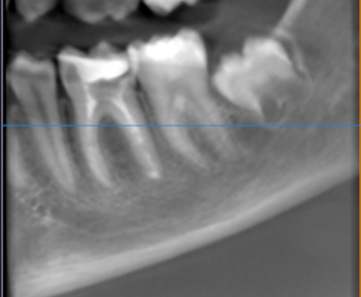

3-DIMENSIONAL VIEW

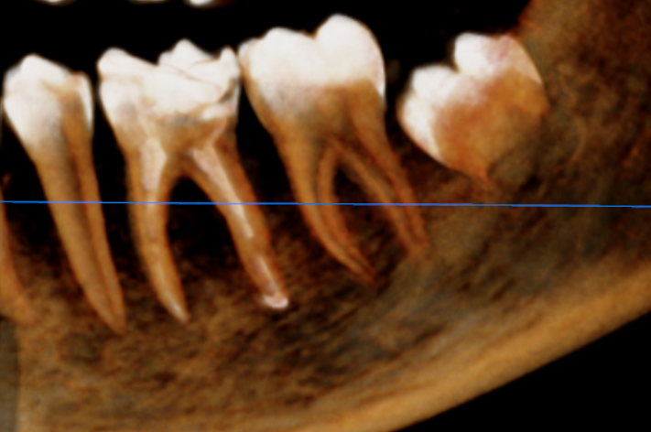

++9CROSS SECTIONAL VIEW

Discontinuity of the restorative material | 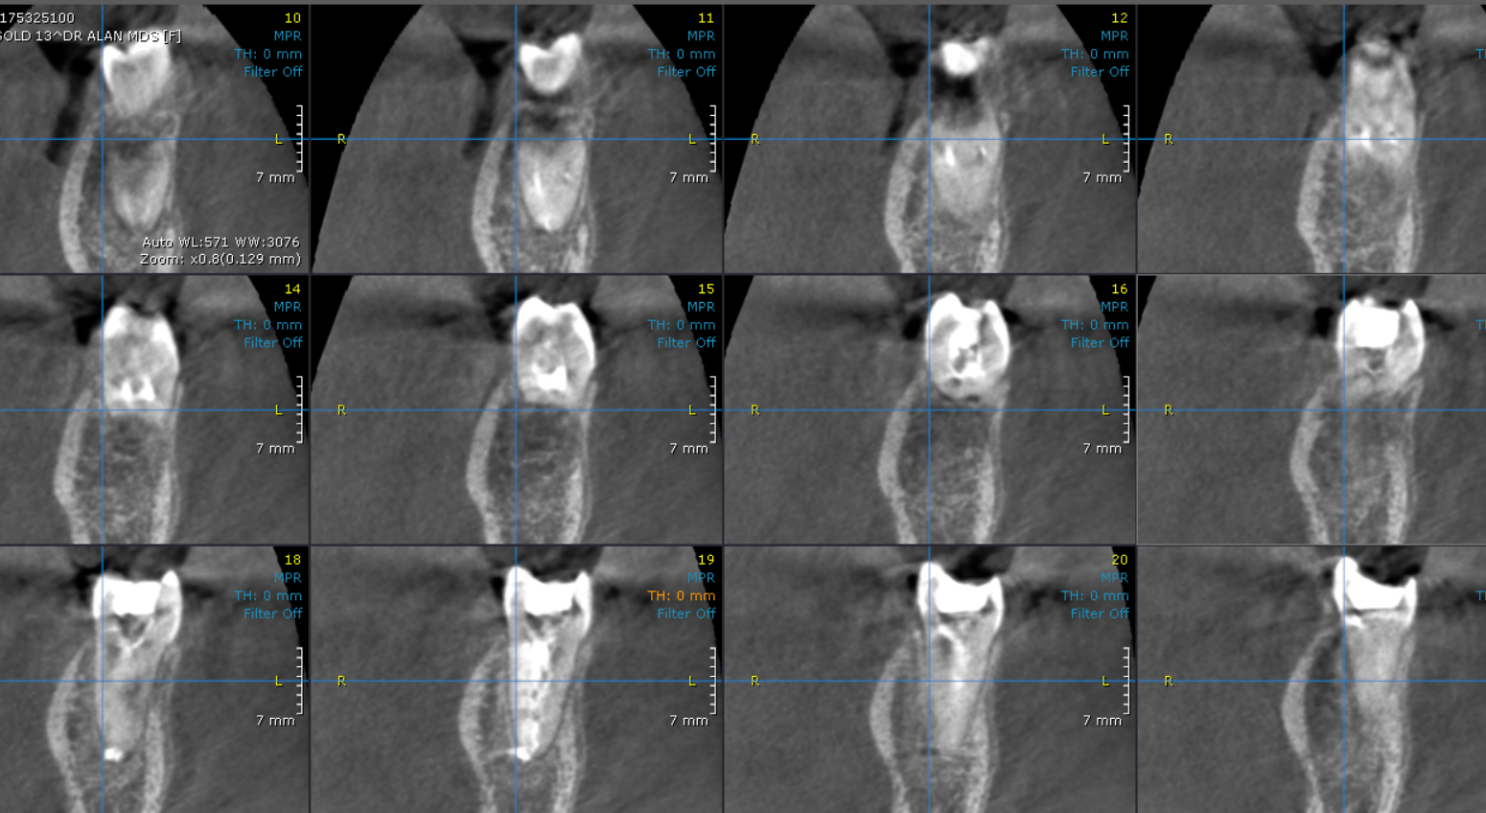

**** End of report ****

